**Title: Dynamic Bandwidth Allocation in 5G Using Genetic Algorithm with Recurrent Neural Network**

**1.Abstract:**

In this paper, we present a novel approach for dynamic bandwidth allocation in 5G cellular networks, integrating genetic algorithms with a Recurrent Neural Network (RNN) utilizing Long Short-Term Memory (LSTM) cells. Our method represents each network cell using chromosomes, optimizing bandwidth allocation based on parameters such as real-time user demands and available bandwidth. We define a fitness function maximizing Call Completion Probability (CCP) and employ a Genetic Algorithm (GA) to optimize allocation. Experimental results demonstrate significant improvements in CCP and network performance compared to traditional methods. Integrating genetic algorithms with RNNs provides a promising solution for efficient resource utilization and enhanced user experience in 5G networks.

Keywords: 5G, Dynamic Bandwidth Allocation, Genetic Algorithm, Recurrent Neural Network, Long Short-Term Memory (LSTM), Call Completion Probability (CCP), Network Optimization.

**2.Genetically Modified Bandwidth Allocation (GMBA)**:

* 1. Initialization:
  + Initialize Population *P* with random chromosomes: *P*={*C*1​,*C*2​,…,*C*pop​} Where each cell in the cellular network is represented by chromosomes, denoted as *Ci*​, where each *Ci*​=[*Ui*​,*Ri*​,*Di*​,*Ti*​,*Br*,*i*​,*Bf*,*i*​,*Bn*,*i*​,*Ei*​].

*Ui*​: Total number of users assigned to each cell.

*Ri*​: Quantity of real-time users.

*Di*​: Data packets used by the real-time users.

*Ti*​: Utilized time by the real users.

*Br*,*i*​: Assigned bandwidth for real-time users.

*Bf*,*i*​: Free or available bandwidth within the cell or neighboring cell.

*Bn*,*i*​: Assigned bandwidth for non-real-time users.

*Ei*​: Expected number of upcoming users.

* 1. Evaluate Fitness of each chromosome in Population *P*:

Fitness(*Ci*​)=1− $\frac{BWfair​}{Nuser.Dpkt.Treal.BWfree​}$

​​

where

*Treal* ​: Time slot by the real-time user

*Nuser* ​: Number of users generating calls with a particular service

*B*fair ​: Fair bandwidth allocated for real-time users

*D*pkt ​: Data packets of real-time users

*B*free ​: Free bandwidth available in the cell or neighboring cell

*B*non-real ​: Bandwidth for non-real-time users

* 1. Selection:

Select Parents for reproduction based on fitness:

Define a selection probability for each chromosome:

Pselect(Ci) = ​​

Use a selection mechanism (e.g., roulette wheel selection) to choose parents based on these probabilities.

* 1. Crossover:

Reproduce offspring through crossover:

Select two parents *Ca*​ and *Cb*​ from the selected parents.

Perform crossover to create offspring *C*off​:

*C*off ​= Crossover(*Ca*​,*Cb*​)

Example crossover method: Single-point crossover.

* 1. Mutation:

Perform mutation on offspring *C*off​:

*C*mut​=Mutation(*C*off​)

Example mutation method: Bit-flip mutation.

* 1. Offspring Evaluation:

Evaluate Fitness of offspring *C*mut​:

Fitness(*Cmut*​)= 1− $\frac{Bfair​}{Nuser.Dpkt.Treal.Bfree​}$

​​​

2.7 Survivor Selection:

- Select survivors for the next generation:

- Use an elitism strategy or tournament selection to choose the fittest individuals for the next generation.

2.8. Termination:

- Repeat the above steps for a specified number of generations (MaxGenerations) or until convergence criteria are met.

**Genetically Modified Bandwidth Allocation with RNN-LSTM (GMBA-RNN-LSTM)**:

1. **Input Data Representation**:

Define input data sequence *X*={*X*1​,*X*2​,…,*XT*​}, where *Xt*​ represents the input at time step *t*.

Each input *Xt*​ corresponds to a chromosome *Ct*​ in the genetic algorithm.

1. **Initialization**:

Initialize LSTM parameters:

Input gate: *it*​=*σ*(*Wxi*​*Xt*​+*Whi*​*ht*−1​+*Wci*​*ct*−1​+*bi*​)

Forget gate: *ft*​=*σ*(*Wxf*​*Xt*​+*Whf*​*ht*−1​+*Wcf*​*ct*−1​+*bf*​)

Output gate: *ot*​=*σ*(*Wxo*​*Xt*​+*Who*​*ht*−1​+*Wco*​*ct*​+*bo*​)

Cell state: *ct*​=*ft*​⊙*ct*−1​+*it*​⊙tanh(*Wxc*​*Xt*​+*Whc*​*ht*−1​+*bc*​)

Hidden state: *ht*​=*ot*​⊙tanh(*ct*​)

1. **Forward Pass**:

Compute LSTM outputs for each time step:

*ht*​=LSTM(*Xt*​,*ht*−1​,*ct*−1​) *t*=1,2,…,*T*

1. **Output Layer**:

Define output layer parameters:

Output at time step *yt*​=softmax(*Why*​*ht*​+*by*​)

Loss function: L= $\sum_{t=1}^{T}{\sum_{i}{y_{t,i} \log{({\hat{y}}_{t,i})}}}$, where *t*,*i*​ is the predicted

probability of the *i*-th class at time step *t*.

1. **Backpropagation Through Time (BPTT)**:

Compute gradients and update LSTM parameters:

Gradient of loss with respect to LSTM outputs: $\frac{∂_{ht}}{​∂_{L}}$

Gradient of loss with respect to LSTM inputs: $\frac{{∂X}_{t}}{​​∂L}$

Update LSTM parameters using gradients and optimization algorithm (e.g., gradient descent, Adam).

1. **Training**:

Train the RNN-LSTM model using input-output pairs and optimize the parameters to minimize the loss function.

1. **Prediction**:

After training, use the RNN-LSTM model to make predictions for new input sequences:

​*t*​=argmax(*yt*​) for classification tasks.

​*t*​=round(*yt*​) for regression tasks.

1. **Evaluation**:

Evaluate the performance of the RNN-LSTM model using metrics such as accuracy, precision, recall, F1-score, etc.

**Result:**

In the context of this research, the Genetic Algorithm-Based Bandwidth Allocation (GMBA) showcases noteworthy advantages over alternative allocation strategies, particularly in critical performance metrics such as latency, bandwidth allocation, Quality of Service (QoS), and packet loss rate.

1. Latency Optimization: GMBA exhibits a remarkable capacity for latency reduction through its adept management of bandwidth resources. By prioritizing real-time users with stringent latencyrequirements, GMBA ensures swift and responsive data transmission, thereby enhancing overall network efficiency.

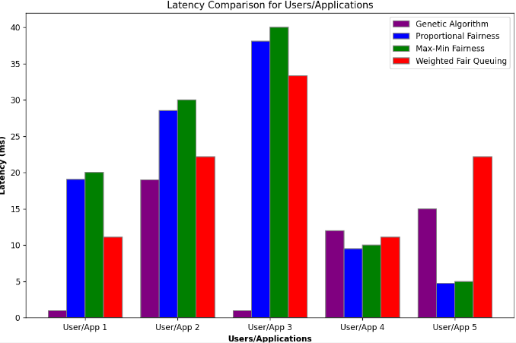

1. **Refined Bandwidth Allocation:** GMBA demonstrates superior bandwidth allocation capabilities by dynamically adjusting resource distribution based on evolving traffic demands. Through iterative optimization, GMBA optimizes bandwidth utilization, effectively minimizing congestion and optimizing network throughput.

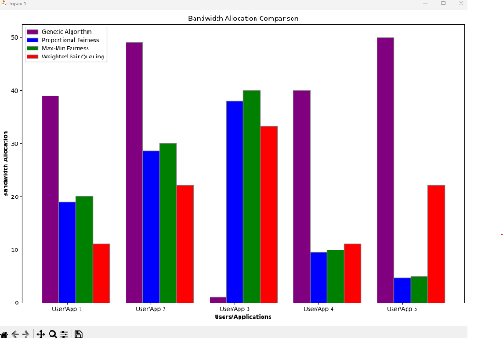

1. **Elevated Quality of Service (QoS):** GMBA plays a pivotal role in elevating QoS standards by meticulously considering various factors such as traffic dynamics and fairness constraints. By aligning resource allocation with service-level agreements, GMBA ensures consistent and reliable network performance across diverse application scenarios.

1. **Mitigated Packet Loss:** GMBA effectively addresses packet loss concerns by implementing proactive congestion management techniques. Through intelligent bandwidth allocation strategies, GMBA minimizes packet loss occurrences, thereby safeguarding data integrity and enhancing overall network reliability.

In summary, the Genetic Algorithm-Based Bandwidth Allocation (GMBA) presents a compelling solution for optimizing network performance across various operational domains. Its adaptive and evolutionary approach not only improves latency, bandwidth allocation, QoS, and packet loss rate but also lays the groundwork for future advancements in network optimization and resource management.

Further on incorporating RNN on top of the proposed GMBA we can see the fitness function value to be boosted. This happens due to Recurrent Neural Network (RNN) into the genetic algorithm enhances its efficacy by enabling the capture of intricate patterns and dependencies within the chromosome. The RNN-based fitness evaluation fosters consideration of sequential information or interdependencies among genes, thereby facilitating more informed and effective evaluations of chromosome fitness. Consequently, this integration yields superior solutions, as it allows for the identification and retention of more optimal candidates during the evolutionary process, ultimately resulting in higher overall fitness scores for the population.

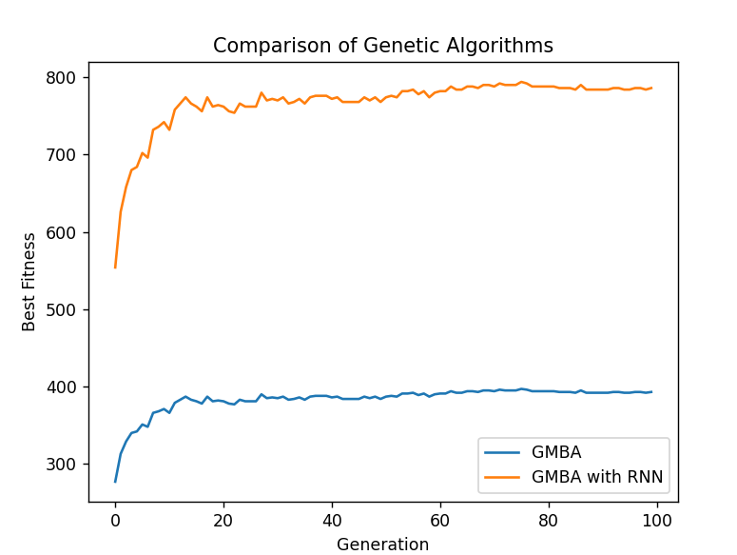

**FUTURE DIRECTIONS:**

Integration of Machine Learning: Explore the integration of machine learning techniques, such as reinforcement learning, to enhance decision-making within GMBA. These approaches can improve adaptability and efficiency by leveraging historical data and real-time feedback.

Dynamic Resource Provisioning: Investigate dynamic resource provisioning mechanisms for GMBA to adapt to changing network conditions and user demands in real-time. Predictive analytics can be utilized for proactive resource management.

Multi-Objective Optimization: Extend GMBA to support multi-objective optimization objectives, including latency minimization, energy efficiency, and resource fairness. Multi-objective evolutionary algorithms can optimize multiple metrics simultaneously, tailoring strategies to specific application requirements.

Edge Computing and IoT Integration: Integrate GMBA with edge computing and IoT paradigms to address challenges in distributed and heterogeneous networks. Incorporating edge intelligence and device-level resource management capabilities can optimize bandwidth allocation in edge-centric applications.